**Information System Management Lab**

**BCOM 307**

**Assignment #17**

***Submitted by:***

**Name:** YASH JAIN

**Enrollment No:** 03914788818

**Semester:** B.Com(H) 5th Semester

**Class:** B.COM(H)

**Section:** B.Com 5A

**Date of Submission:** 18/10/2021

***Submitted to:***

**Praveen Kumar Singh**

**Assistant Professor, MAIMS**



**Department of Commerce**

**Maharaja Agrasen Institute of Management Studies**

**Affiliated to Guru Gobind Singh Indraprastha University, Delhi**

**Sector -22, Rohini, Delhi -110086, India; www.maims.ac.in**

Maharaja Agrasen Institute of Management Studies

Affiliated to GGS IP University; Recognized u/s 2(f) of UGC Recognized by Bar Council ofIndia; ISO 9001: 2015

Certified Institution Sector 22, Rohini, Delhi -110086, India; [www.maims.ac.in](http://www.maims.ac.in/)

Department of Commerce

Academic Year: 2020-21

Semester: Vth

# Assignment No. 17

# Unit No:

**Course/Subject Code:** BCOM 307 **Subject Title: Information System Management Lab**

# Issue Date Last Date of Submission:

**Instructions for Students:**

# All Questions are Compulsory.

1. The student should attach proper cover page for each assignment clearly mentioning the Assignment No.
2. Each assignment should be prepared by the student individually with proper explaination and screenshots.
3. A4 size ruled sheets should be used for the assignment.
4. Assignment pages should be serially numbered at the bottom of page.

***During online education mode, upload scanned copy of the complete assignment including cover page latest by due date.***

|  |  |  |
| --- | --- | --- |
| **Question No.** | **Question** | **CO No.** |
| 1 | Display the number of clients in each city. | **CO1, CO2, CO3, CO4** |
| 2 | Display the number of clients in each designation. |
| 3 | Display cities where no of clients is greater than or equal to 2. |
| 4 | Display the number of clients for each designation where the count is more than equal to 2. |
| 5 | Display the cities where bal due is more than 5000 and no of clients is more than 2. |

**ASSIGNMENT 17 - GROUP BY and HAVING Clause**

**Task 1 : Display the number of clients in each city.**

This task can be completed using the **GROUP BY** clause. The GROUP BY clause is used to filter the data in a table, according to one of the columns. It is used for categorical data. You have to write the column name with GROUP BY, on which the aggregate function hasn't been

applied. The syntax for this is -

SELECT column1, agg_function(column2) from <tablename> where <condition> GROUP BY column1,column2;

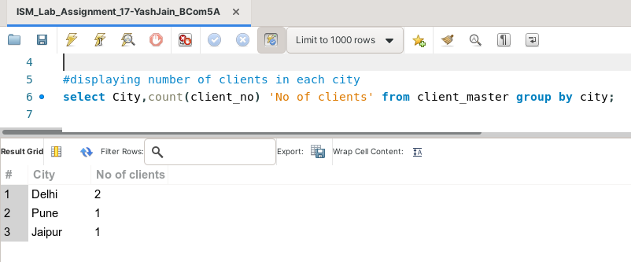

**Task 2: Display the number of clients in each designation.**

This task can be completed using the **GROUP BY** clause.

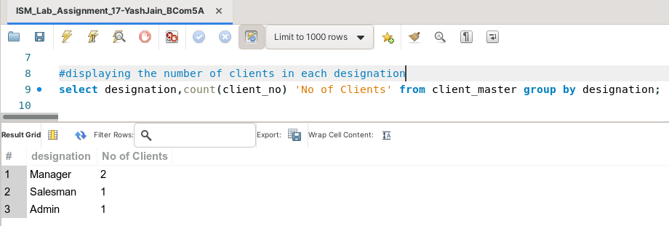

**Task 3: Display cities where no of clients is greater than or equal to 2.**

This task can be completed using the **GROUP BY** clause, along with the **HAVING** clause. The HAVING clause is used after the GROUP BY clause which is used to display records satisfying a particular condition in the group that we have virtually created using the GROUP BY clause. So, the HAVING Clause filters the Virtual Group. The syntax for this is -

SELECT column1, agg_function(column2) from <tablename> where <condition> GROUP BY column1,column2 HAVING <condition>;

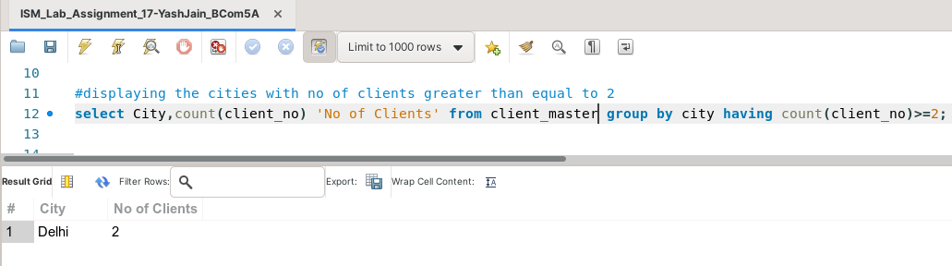

**Task 4: Display the number of clients for each designation where the count is more than equal to 2.**

This task can be completed using the **GROUP BY** clause, along with the **HAVING** clause.

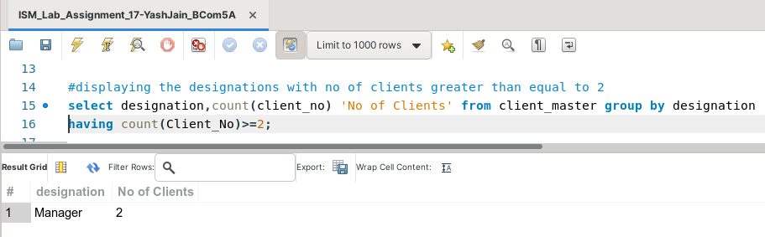

**Task 5: Display the cities where bal due is more than 5000 and no of clients is more than 2.**

This task can be completed using the **GROUP BY** clause, along with the **HAVING** clause, and the **WHERE** clause.

